**DELHI PUBLIC SCHOOL**

**DEHRADUN**

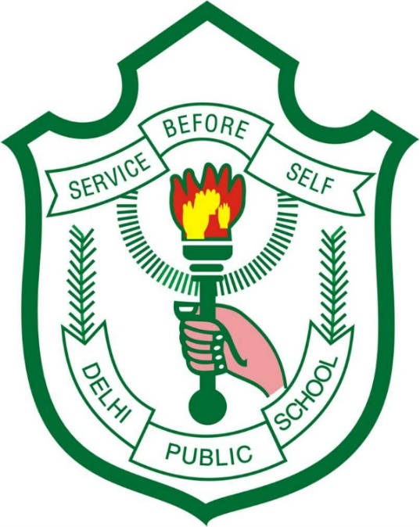

**SESSION: 2016-17**

**SUBMITTED BY: MAYANK BHANDARI**

**CLASS: 12TH A**

**SUBJECT: PHYSICAL EDUCATION**

**SUBMITTED TO: MANOJ SHARMA**